SIMATS ENGINEERING
ASSESSMENT TOOL 3

COURSE NAME: Artificial Intelligence COURSE CODE: CSA17

COURSE OUTCOME COVERED

CO2: Experiment search and game-solving techniques such as Greedy Search, A*, CSP, Minimax, and Alpha-Beta pruning with heuristic functions for solving complex AI problems efficiently. (BL3)

Assessment Tool Weightage: 40%

Duration: 1 Hour
QUESTIONS: 3 Total Marks:30

Annexure A

Dry Run Evaluation

Code of Conduct:

I S.K. Deepa Arathi / 192571020 (Name / Reg No) certify that this submission is my original work and that I have adhered to the guidelines specified for this assessment.
I understand that any violation of academic integrity rules will result in disciplinary action.

Signature of the student:

Annexure A

Dry Run Evaluation
1. Question 1 – Breadth-First Search (BFS)
Consider the following graph: A
/ \
B C
/ \ / \
D E F G
Task: Starting from node A, perform a Breadth-First Search (BFS). Complete the following table.
Iteration | Queue | Visited Node
1
2
3
4
5
6
7
Questions:
- Write the BFS traversal order.
- Show the queue contents after each iteration.


2. Depth-First Search (DFS) Using the same graph,
A
/ \
B C
/ \ / \
D E F G
Perform Depth-First Search (DFS) starting from A.
Complete the table.
- Initial State :
1 3 6
5 0 2
4 7 8

Goal State :
1 2 3
4 5 6
7 8 0

Task
Trace Breadth-First Search (BFS) until the goal state is reached.
Fill in the table.
Iteration | Current State | Queue Before Expansion | Queue After Expansion
1
2
3
4
5

Questions
- Which node is expanded in each iteration?
- How many states are generated in total?
- Write the complete solution path from the initial state to the goal state.
- Why does BFS always find the shortest solution in an unweighted 8-puzzle problem?

RUBRICS FOR CALCULATION

Criteria | Weightage (%) | Level 4 – Exemplary (4) | Level 3 – Proficient (3) | Level 2 – Developing (2) | Level 1 – Beginning (1)
Understanding of Search Problem | 20 | Clearly understands the search problem, initial state, goal state, and search strategy. | Understands the problem with minor misunderstandings. | Demonstrates partial understanding of the search problem. | Shows little or no understanding of the search problem.
State Expansion and Dry Run Execution | 30 | Correctly traces every iteration, expands nodes accurately, and maintains the Queue/Stack/Priority Queue without errors. | Performs most iterations correctly with minor mistakes in state expansion or data structure updates. | Performs only some iterations correctly; several errors in tracing or node expansion. | Unable to correctly perform the dry run or expand states.
Application of Search Algorithm | 20 | Applies the selected algorithm (BFS/DFS/UCS) correctly, following all algorithmic rules. | Applies the algorithm correctly with a few procedural errors. | Applies only basic algorithm steps with noticeable mistakes. | Fails to apply the correct search algorithm.
Accuracy of Solution Path | 20 | Identifies the correct traversal order/solution path and goal state with proper justification. | Solution path is mostly correct with minor errors. | Partially correct solution path; goal may not be reached correctly. | Incorrect or incomplete solution path.
Presentation and Logical Reasoning | 10 | Queue/Stack/Priority Queue updates, state diagrams, and explanations are neat, organized, and logically presented. | Presentation is clear with minor organizational issues. | Limited explanation and organization; reasoning is partially clear. | Poor presentation with unclear or missing reasoning.

Question 1: Breadth-First Search (BFS)
1.1 Understanding the Problem
The graph given in the question is a binary tree. Node A is the root, B and C are its children, B has the children D and E, and C has the children F and G. We have to start at A and visit the nodes using Breadth-First Search and fill the table showing the queue and the visited node in each iteration.
Breadth-First Search explores a graph level by level. It first visits the start node, then all the nodes that are one edge away, then all the nodes two edges away, and so on. To do this it uses a queue, which is a First-In-First-Out (FIFO) data structure: the node that enters the queue first is the first to leave it. The algorithm is as follows.
- Put the start node A into the queue and mark it as discovered.
- Repeat while the queue is not empty: remove the node at the front of the queue and visit it.
- Add all the children (unvisited neighbours) of the visited node to the rear of the queue, from left to right.
- Stop when the queue becomes empty (or when the goal is found).
1.2 Dry Run of BFS from Node A
In the table below, the column "Queue" shows the contents of the queue at the start of the iteration (front on the left), and the column "Visited Node" shows the node removed from the front and visited. I have added one more column to show the queue after the children are inserted, because the second question asks for the queue contents after every iteration.
Iteration | Queue (before removing) | Visited Node | Queue after adding children
1 | A | A | B, C
2 | B, C | B | C, D, E
3 | C, D, E | C | D, E, F, G
4 | D, E, F, G | D | E, F, G
5 | E, F, G | E | F, G
6 | F, G | F | G
7 | G | G | (empty)

Table 1.1: BFS dry run on the given graph
1.3 Answers to the Questions
(i) BFS traversal order
The BFS traversal order is A → B → C → D → E → F → G.
Level 0 contains A, level 1 contains B and C, and level 2 contains D, E, F and G, so the nodes are visited exactly in the order of their levels, and from left to right inside a level.
(ii) Queue contents after each iteration
After iteration | Node removed | Children added | Queue contents (front → rear)
1 | A | B, C | B, C
2 | B | D, E | C, D, E
3 | C | F, G | D, E, F, G
4 | D | none (leaf) | E, F, G
5 | E | none (leaf) | F, G
6 | F | none (leaf) | G
7 | G | none (leaf) | empty

Table 1.2: Queue after every iteration
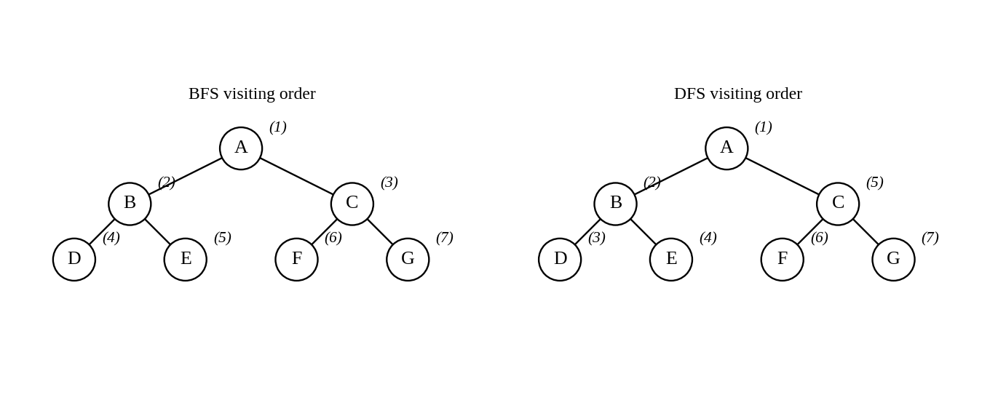
Figure 1.1: Order in which the nodes are visited by BFS (left) and DFS (right)

1.4 Observations
- The queue length first grows (maximum of 4 nodes after iteration 3) and then shrinks, because the leaves D, E, F and G have no children to add. The maximum size of the queue is equal to the widest level of the tree, so the space needed by BFS is O(b^d).
- All 7 nodes were visited once, and each node entered the queue only once. The time taken is O(b^d), which here is the number of nodes in the tree.
- If node G were the goal, BFS would find it at depth 2, which is the shallowest depth at which it exists. This is why BFS is complete and gives the shortest path when all the edges have the same cost.

Question 2: Depth-First Search (DFS)
2.1 Understanding the Problem
For the same graph we now have to perform Depth-First Search from node A and fill in a table with the columns Iteration, Stack and Visited Node. DFS goes as deep as possible along one branch before coming back and trying the next branch. It uses a stack, which is a Last-In-First-Out (LIFO) data structure, so the node that was pushed last is removed first.
- Push the start node A onto the stack.
- Repeat while the stack is not empty: pop the node from the top of the stack and visit it.
- Push the children of the visited node onto the stack. The children are pushed from right to left (G before F, C before B and so on) so that the left child ends on top of the stack and is explored first.
- Stop when the stack is empty or the goal is found.
2.2 Dry Run of DFS from Node A
The stack is written with the top on the left. The column "Stack" shows the stack at the start of the iteration, and the next column shows the stack after the children of the visited node were pushed.
Iteration | Stack (top on left) | Visited Node | Stack after pushing children
1 | A | A | B, C
2 | B, C | B | D, E, C
3 | D, E, C | D | E, C
4 | E, C | E | C
5 | C | C | F, G
6 | F, G | F | G
7 | G | G | (empty)

Table 2.1: DFS dry run on the given graph
The DFS traversal order is A → B → D → E → C → F → G. After A the algorithm goes to its left child B and then to B's left child D. D is a leaf, so it backtracks (pops the next item from the stack) to E, which is also a leaf. Now the whole left subtree of A is finished, and only then does the stack give C, and the same process is repeated for the right subtree.
2.3 Comparison of BFS and DFS on this Graph
Point | BFS | DFS
Data structure | Queue (FIFO) | Stack (LIFO) or recursion
Traversal order here | A, B, C, D, E, F, G | A, B, D, E, C, F, G
Maximum size of the data structure in this example | 4 nodes (D, E, F, G) | 3 nodes (D, E, C)
Memory in general | O(b^d), stores a whole level | O(b·m), stores only one path with its siblings
Completeness | Complete (finite branching) | Not complete in infinite or cyclic graphs without a visited list
Optimality (equal edge costs) | Gives the shallowest goal | Does not guarantee the shallowest goal
Time complexity | O(b^d) | O(b^m)
Best used when | The solution is near the root, or the shortest path is needed | The solution is deep, memory is small, or all solutions are needed

Table 2.2: BFS versus DFS (b = branching factor, d = depth of the shallowest goal, m = maximum depth)
In the example the stack never holds more than three nodes, while the queue of BFS reached four nodes, which shows why DFS needs less memory. On the other hand, if the goal were node C, BFS would reach it at its third visit, whereas DFS would reach it only on its fifth visit, after exploring the entire subtree of B. So the choice of the algorithm depends on the nature of the problem.
The visited list is also important. In this graph there are no cycles, so no node can be reached twice, and the visited list is not needed. In a general graph a visited set must be maintained, otherwise DFS can run forever around a cycle.
Question 3: BFS on the 8-Puzzle Problem
3.1 Problem Formulation
The 8-puzzle is played on a 3 x 3 board with eight numbered tiles and one blank. In one move a tile next to the blank slides into the blank, which is the same as moving the blank up, down, left or right. We are asked to trace BFS from the given initial state to the goal state.
Initial State | Goal State
1 3 6 | 1 2 3
5 0 2 | 4 5 6
4 7 8 | 7 8 0

Table 3.1: Initial and goal states (0 stands for the blank)
Element | Description
State | An arrangement of the 8 tiles and the blank on the 3 x 3 board (9! = 362,880 arrangements, half of which are reachable from any one state)
Initial state | 1 3 6 / 5 0 2 / 4 7 8
Goal state | 1 2 3 / 4 5 6 / 7 8 0
Operators | Move the blank Up, Down, Left, Right (when the move stays inside the board)
Path cost | Each move costs 1, so the cost of a path is the number of moves
Move order used in my trace | Up, Down, Left, Right (applied to the blank), and a state that has already been generated is not added again

Table 3.2: Formulation of the problem
Before starting I checked that a solution exists. Writing the tiles in a row (ignoring the blank) gives 1 3 6 5 2 4 7 8. The inversions are: 3 > 2 (1), 6 > 5, 6 > 2, 6 > 4 (3), and 5 > 2, 5 > 4 (2), which gives 6 inversions in total. Since the number is even and the goal state also has zero inversions, the initial state belongs to the same half of the state space as the goal, so it is solvable.
3.2 How the Trace is Written
To keep the queues short and readable I have given every generated state a name S0, S1, S2, ... in the order in which it is generated. S0 is the initial state. Because BFS uses a FIFO queue, the states leave the queue in exactly the order of their numbers, so iteration k always expands state S(k−1). The blank is written as 0.
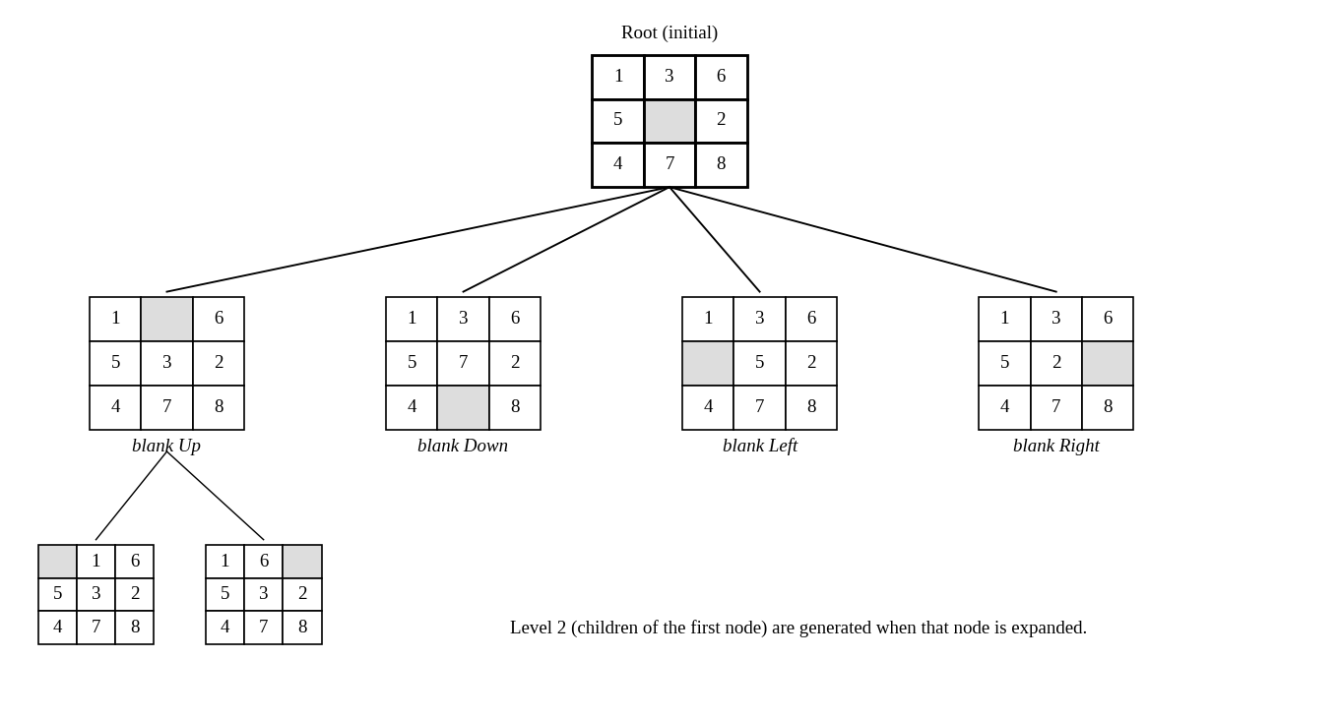
Figure 3.1: The initial state and the states generated by the first expansions
State | Board (row by row) | Generated from | Move of blank
S0 | 1 3 6 / 5 0 2 / 4 7 8 | - | -
S1 | 1 0 6 / 5 3 2 / 4 7 8 | S0 | Up
S2 | 1 3 6 / 5 7 2 / 4 0 8 | S0 | Down
S3 | 1 3 6 / 0 5 2 / 4 7 8 | S0 | Left
S4 | 1 3 6 / 5 2 0 / 4 7 8 | S0 | Right
S5 | 0 1 6 / 5 3 2 / 4 7 8 | S1 | Left
S6 | 1 6 0 / 5 3 2 / 4 7 8 | S1 | Right
S7 | 1 3 6 / 5 7 2 / 0 4 8 | S2 | Left
S8 | 1 3 6 / 5 7 2 / 4 8 0 | S2 | Right
S9 | 0 3 6 / 1 5 2 / 4 7 8 | S3 | Up
S10 | 1 3 6 / 4 5 2 / 0 7 8 | S3 | Down
S11 | 1 3 0 / 5 2 6 / 4 7 8 | S4 | Up
S12 | 1 3 6 / 5 2 8 / 4 7 0 | S4 | Down

Table 3.3: Key to the first 13 states
3.3 BFS Dry Run Table (First Five Iterations)
Iteration | Current state (expanded) | Queue before expansion | Queue after expansion
1 | S0 (136502478) | S0 | S1, S2, S3, S4
2 | S1 (106532478) | S1, S2, S3, S4 | S2, S3, S4, S5, S6
3 | S2 (136572408) | S2, S3, S4, S5, S6 | S3, S4, S5, S6, S7, S8
4 | S3 (136052478) | S3, S4, S5, S6, S7, S8 | S4, S5, S6, S7, S8, S9, S10
5 | S4 (136520478) | S4, S5, S6, S7, S8, S9, S10 | S5, S6, S7, S8, S9, S10, S11, S12

Table 3.4: First five iterations of BFS (the goal is not yet reached)
The table has only five rows, but the goal is not reached in five iterations. BFS has to continue until the goal state comes to the front of the queue. In my trace this happens at iteration 311, so the complete trace has 311 iterations. Writing all the queues in full is not practical, because the queue holds up to 190 states, so I have given the remaining iterations in a compact form in the Appendix at the end of this document (the state that is expanded and the new states that are added).
Reading the first rows: in iteration 1 the initial state S0 is expanded, and since the blank is in the centre it has four children S1 to S4 (blank moved Up, Down, Left, Right). In iteration 2 the first child S1 is expanded. The blank is now at the top, so it can only move Left or Right (moving Down would only give S0 again, which is already generated), and it adds S5 and S6. The same happens for S2, S3 and S4 in the next iterations, as the queue column shows.
3.4 Answers to the Questions
(i) Which node is expanded in each iteration?
The states are expanded in the order of generation, so iteration k expands S(k−1). For the first five iterations the expanded states are S0, S1, S2, S3 and S4, as in Table 3.4. The states of the later iterations are listed in the Appendix. The number of states expanded at each depth is given below.
Depth | Moves from start | States removed from the queue at this depth | Iterations
0 | 0 | 1 | 1 – 1
1 | 1 | 4 | 2 – 5
2 | 2 | 8 | 6 – 13
3 | 3 | 8 | 14 – 21
4 | 4 | 16 | 22 – 37
5 | 5 | 32 | 38 – 69
6 | 6 | 60 | 70 – 129
7 | 7 | 72 | 130 – 201
8 | 8 | 110 | 202 – 311

Table 3.5: Level-wise summary of the BFS run
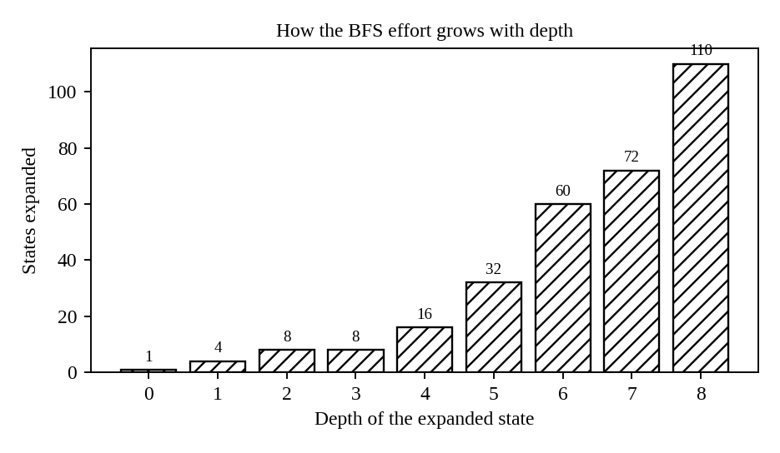
Figure 3.2: Number of states handled at each depth
All states of depth 0 to 7 were processed completely before any state of depth 8 was taken. The goal is one of the depth 8 states, and it is reached after 310 earlier states have been expanded, so it is the 311th state to leave the queue.
(ii) How many states are generated in total?
Counting the initial state, a total of 500 states were generated (S0 to S499). Out of these, 311 states were removed from the queue (the last one being the goal, which is not expanded), so 310 states are expanded, and the remaining 189 states are still waiting in the queue when the search stops. Duplicate states (states that were already generated) are not counted, because the visited check rejects them.
Quantity | Value
States generated (including the initial state) | 500
States removed from the queue (iterations) | 311
States expanded (children generated) | 310
States left in the queue at the end | 189
Depth of the goal | 8
Largest size of the queue | 190

Table 3.6: Summary of the work done by BFS
If the goal test were done at the time of generation instead of at removal from the queue, the search would stop a little earlier and fewer states would be generated, but the solution and its length would be the same.
(iii) Complete solution path from the initial state to the goal state
The shortest solution has 8 moves. Moving the blank each time, the sequence is Right, Up, Left, Down, Left, Down, Right, Right. The states along the path are given below.
Step | Move of blank | Board (row by row)
0 | - | 1 3 6 / 5 0 2 / 4 7 8
1 | Right | 1 3 6 / 5 2 0 / 4 7 8
2 | Up | 1 3 0 / 5 2 6 / 4 7 8
3 | Left | 1 0 3 / 5 2 6 / 4 7 8
4 | Down | 1 2 3 / 5 0 6 / 4 7 8
5 | Left | 1 2 3 / 0 5 6 / 4 7 8
6 | Down | 1 2 3 / 4 5 6 / 0 7 8
7 | Right | 1 2 3 / 4 5 6 / 7 0 8
8 | Right | 1 2 3 / 4 5 6 / 7 8 0

Table 3.7: States on the solution path
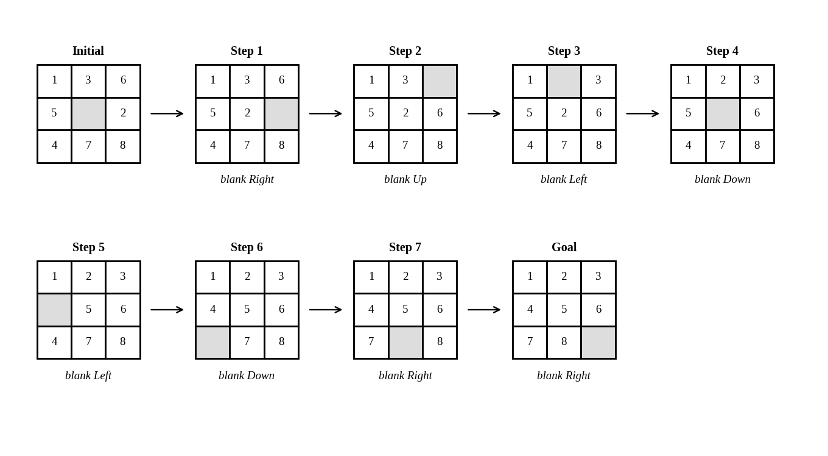
Figure 3.3: The solution path from the initial state to the goal state (grey square = blank)
In terms of tiles, the moves are: tile 2 slides left, tile 6 slides down, tile 3 slides right, tile 2 slides up, tile 5 slides right, tile 4 slides up, tile 7 slides left and tile 8 slides left, which is the same as the blank moving as written above. Checking the last board in the table confirms that it equals the goal 1 2 3 / 4 5 6 / 7 8 0.
(iv) Why does BFS always find the shortest solution in an unweighted 8-puzzle?
- Level-by-level expansion: BFS removes states from the queue in the order of their depth. All the states at depth d are removed before any state at depth d + 1. This follows from the FIFO queue, because the children of a depth d state are added behind all the depth d states that are already waiting.
- Equal step cost: in the 8-puzzle every move costs 1, so the depth of a state is exactly the cost of the path that reaches it. The first time a state is generated is therefore by the cheapest path.
- Goal at the smallest depth: suppose a solution of length n exists. Then all states of depth less than n are expanded first and none of them is the goal. So the first time the goal appears it is at depth n, the smallest possible, and no shorter solution could have been missed.
- Completeness: the number of states is finite (362,880) and the branching factor is at most 4, and with the visited check every state is handled at most once, so BFS always terminates, and it finds a solution whenever one exists.
The price of this guarantee is memory and time. The number of states grows roughly as b^d, and the queue has to keep all of them. In this example, depth 8 needed 311 removals and 500 generated states, and for harder puzzles with a solution of depth 20 or more, BFS becomes impractical. Informed methods such as A* with the Manhattan distance heuristic find the same shortest solutions while generating far fewer states.
iterations (U = blank moved up, D = down, L = left, R = right)

